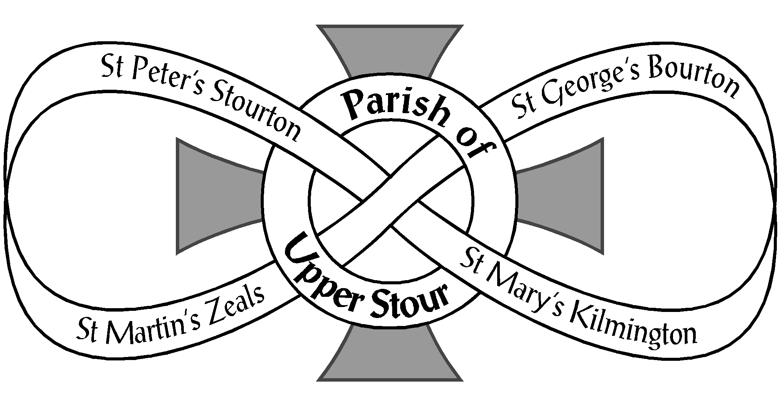

Looking to God, Looking to Care, Looking to Grow

The Annual Parish Meeting and Annual Parochial Church Meeting
Thursday 13th April 2023 at 7.00 pm in Zeals Village Hall
A G E N D A
ANNUAL PARISH MEETING
- Opening Prayers
- Apologies
- Minutes of the last meeting 19th May 2022
- Proposal to disregard Church Warden Measure 6-year rule in line with the Churchwarden Measure 2001 Point 3
- Election of Churchwardens (Open to all those on the Civic and Church Electoral Rolls)
ANNUAL PAROCHIAL CHURCH MEETING
Open to those on the Church Electoral Roll (CER)
- Church Wardens’ reports on the fabric, goods and ornaments of each Church and
presentation of Church Inventories
- PCC Annual Report
- Treasurer’s Report and Adoption of Accounts
- Appointment of Examiner of PCC Accounts
- Deanery Synod Report
- Election of Deanery Synod representatives x 3 (Open to those on the CER)
- Appointment of Electoral Roll Officer (Open to those on the CER)
- Report on and reception of the Church Electoral Roll
- Proposal to allow for six elected PCC members and for elected members to serve yearly terms
- Election of Parochial Church Council representatives x 6 (Open to those on the CER)
- Vice Chair’s Report
- Any other business (helpful if raised with Secretary or Chairman 24 hrs. in advance)
- Date of next meeting – TBC
- Closing Prayers
************

There will be a short meeting of the PCC to elect officers following the APCM, including
nominations to Local Church Committees, Asst. Wardens, Sidespeople & Safeguarding Officer

