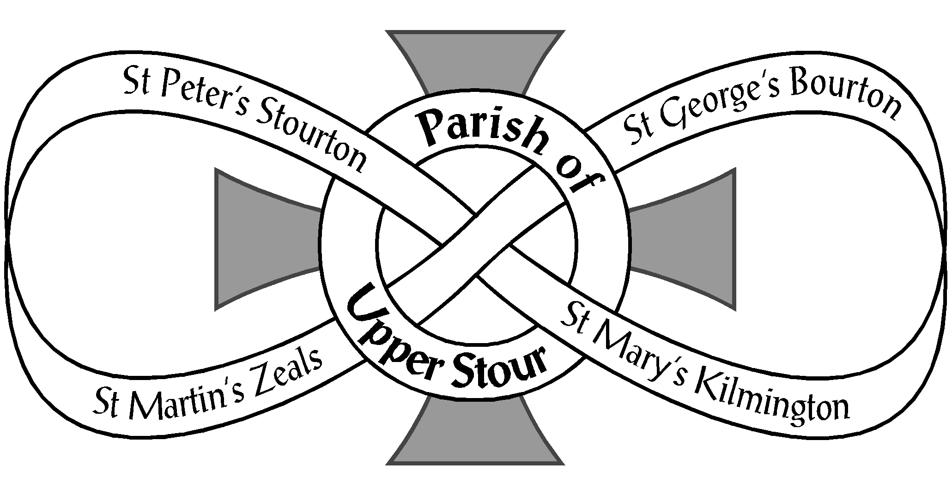

Looking to God, Looking to Care, Looking to Grow

Minutes of the Annual Parish Meeting and Annual Parochial Church Meeting
Thursday 19th May 2022 at 7.00 pm in St. George’s School Hall, Bourton

ANNUAL PARISH MEETING

- Opening Prayers - Rev. Ben opened the meeting with a prayer and chaired this first meeting

- Apologies – Malcolm Affleck, Colin Holman, Graham Poynton, Mona Tyler

- Minutes of the last meeting 13th May 2021 – these had been available on the website and were approved.

- Proposal to disregard Church Warden Measure 6-year rule in line with the Churchwarden Measure 2001 Point 3 - Rev. Ben explained the measure – the hope is to share the responsibility.
The measure was approved.

- Election of Churchwardens (Open to all those on the Civic and Church Electoral Rolls)

The following were re-elected:

St. George’s, Bourton - Mrs. Margaret Martin
St. Mary’s, Kilminton - Mrs. Celia Cotton and Mr. Chris Reeves
St. Peter’s, Stourton - Mrs. Jane Parker and Mrs. Crin Fearon
St. Martin’s, Zeals – Miss Sue Evans

Rev. Ben thanked all the Church Wardens and reiterated their value.

Crin Fearon was proposed as Vice Chair, to take the helm during the vacancy, by Sue Evens
and seconded by Ashley Kemp.

Rev. Ben added that there would be a visitation by the Archdeacon before 31st July.

ANNUAL PAROCHIAL CHURCH MEETING
Open to those on the Church Electoral Roll (CER) Crin Fearon chaired this meeting

- Church Wardens’ reports on the fabric, goods and ornaments of each Church and
presentation of Church Inventories – Rev. Ben signed three inventories and will sign Zeals inventory
next week.

2. PCC Annual Report – There were no comments or queries.

3. Treasurer’s Report and Adoption of Accounts – Margaret Martin thanked Ashley Kemp for
such a positive report.

4. Appointment of Examiner of PCC Accounts – Peter Clarke had been appointed on a one year
basis and Ashley Kemp would be recommending a new Examiner to the PCC shortly.
- 2 –

5. Deanery Synod Report – Malcolm Affleck’s report was read out in his absence.
Heytesbury Deanery Report 2021
Early summer saw the start of a new triennium followed by the ‘election’ of representatives to the Diocesan
Synod; as in recent times this was almost by appointment.

At the end of September we had a real election of lay representatives to the General Synod. Both Lay and
Clergy Houses are elected simultaneously by their respective electorates and those successful serve for a
period of five years. For the House of Laity we had thirteen candidates for six seats. Voting is by electronic
voting portal or post for those without internet connection. Candidates are allowed to submit online a two
page election address and zoom hustings were also held. Party lines are taken, high church, low church,
evangelical, middle of the road and this year supporters of Save the Parish Network. I should add that those
elected are expected to become fully acquainted with the 127 pages of Standing Orders that ensure the
smooth and swift running of synod sessions.

Synod met in October and as the Rural Dean, Revd. Pauline Reid, reminded us this was the first in almost two
years. For more than a third present this was their first Synod and so a longer form of worship was used.
Robert Shuler, Lay Chairman, spent time introducing the activities of Synod and current issues, these included
the shortfall in Share contributions, the recent Giving Campaign, the continuing review of the Share system,
clergy numbers and posts. Pauline and Robert answered as best they could the questions that came from
those present.

The next Synod is proposed to be held late spring 2022.

6. Appointment of Electoral Roll Officer (Open to those on the CER)
Elizabeth Hames was thanked for being willing to stand again.

7. Report on and reception of the Church Electoral Roll

THE PARISH OF UPPER STOUR ELECTORAL ROLL REPORT 2021 2022
THIS IS THE REVISION OF THE ROLL

One New Applicant registered on the roll for 2022
At the close of registration for 2021 there were 106 on the roll
Through the year the numbers have decreased by 2

This breaks down as follows
BOURTON: One person came off
KILMINGTON: One person came off
STOURTON: No change
ZEALS: One new person came on and One came off
NON-RESIDENTS: No change

BOURTON: 27 Residents
KILMINGTON: 23 Residents
STOURTON: 17 Residents
ZEALS: 34 Residents
NON-RESIDENTS: 3 Residents

TOTAL ON ROLL IN 2022 104 (One hundred and four)

8. Proposal to allow for six elected members as per CRR2020 M15(9) and for elected members
to serve yearly terms as per CRR2020 M16(2) – Approved.

- 3 -

9. Election of Parochial Church Council representatives x 6 (subject to previous item)
(Open to those on the CER)

Liz Kemp proposed and Chris Reeves seconded the election of the following five, leaving a vacancy,
which no-one came forward to fill:-

Mrs. Caroline Worthington
Mr. Ashley Kemp
Mr. Colin Holman
Mrs. Jane Joyce
Mr. George Bullivant

10. Incumbent’s Report – as per PCC Annual Report

The year of 2021 wasn’t quite the great ‘unlocking’ we had hoped for. However, I am pleased with how
much we have managed to achieve in this year with many challenges to acknowledge along the way.
Jane’s PCC report presents the work of the PCC. I am very grateful to our PCC and LCC members in
the Parish of Upper Stour, for continuing to have a passion for their churches, and working to honour their
legacy, nurture their current life, and to have faith in their future. Our council and respective
committees have officers who coordinate, administrate, and financially care for each of our churches and for
this I and the Church of England am indebted to you. Thank you.

Beyond the life of the PCC and its committee structure, the life of church has continued in the faith of Christ
as we grow in faith, hope and love. There are certainly challenges on the horizon for the Church of England as
a whole, and indeed locally, however, 2021 continued to present the bread and butter of Parish Ministry that
brings us growth and faith as a gathered community. As can be seen below, we continued to be asked to be
with people in their sorrow, joy and thanksgiving through the occasional offices. For those who feel a particular
religious affinity with Christmas and Easter we were open, hospitable and enjoyed welcoming the wider
community.

The national church in this year has begun to think about what it means to be a church which thrives in being
bolder, simpler and humbler. A Christ centred church of missionary disciples, which strives to be younger and
more diverse, where a ‘mixed ecology’ is the norm. This vision will move us forward into the 2020s and we
will no doubt begin to understand more fully what this may look like for the Parish of Upper Stour. In 2021
our neighbouring incumbent in Mere, Maiden Bradley and West Knoyle, Rev’d Carol Green, was appointed as
Priest in Charge of the Haldon Mission Community in the Diocese of Exeter. This has caused Upper Stour to
be invited to think more deeply about how it may work more with its neighbouring benefice, and how to
encourage our growth of faith in this part of the Church of England and the Anglican Communion.

The lives of our four churches (each with their own vocation and life), the life of our two church schools (both
distinctive and with their own vision and values for the future), and the pastoral life of our parishioners
continues to give me hope, that we are still communing in the life of Christ in this place, and I look forward to
seeing how that moves into the future.

Occasional Offices: Baptisms 10 Weddings 12 Funerals 8
Easter - Across our three Easter day services in Upper Stour we had 83 people attend.
Christmas - Across our four church services in Upper Stour on Christmas Eve and Christmas Day we had 250
people attend. We also enjoyed Carols Around…, The Green in Zeals, The War Memorial in Kilmington, and
The Tree in Bourton These drew in around 30-100 each.

Rev’d Ben Rundell-Evans
Priest in Charge and Chair of the PCC

- 4 -

Margaret Martin asked Rev. Ben how much Covid had affected church growth and attendance. He answered
that looking at the registers, it was comparable with previous years – not much change in numerical
attendance. And similarly with the Electoral Roll. Caroline Worthington commented that there had been a
decline in families with children. She had a Toddler Group and Toddler Worship and would be trying All Age
Worship to see how it goes. She and Jane Parker remembered bringing their own children originally.
Rev. Ben added that 56% of the local school children come from outside our catchment area. He said it was
worth looking at the attendance registers.

11. Any other business – there was none

12. Date of next meeting – TBC before 31st May 23

13. Closing Prayers
************

20 attended the meeting and there was a jolly gathering afterwards with
refreshments, marked by the fact that regretfully it was Rev. Ben’s last meeting.

