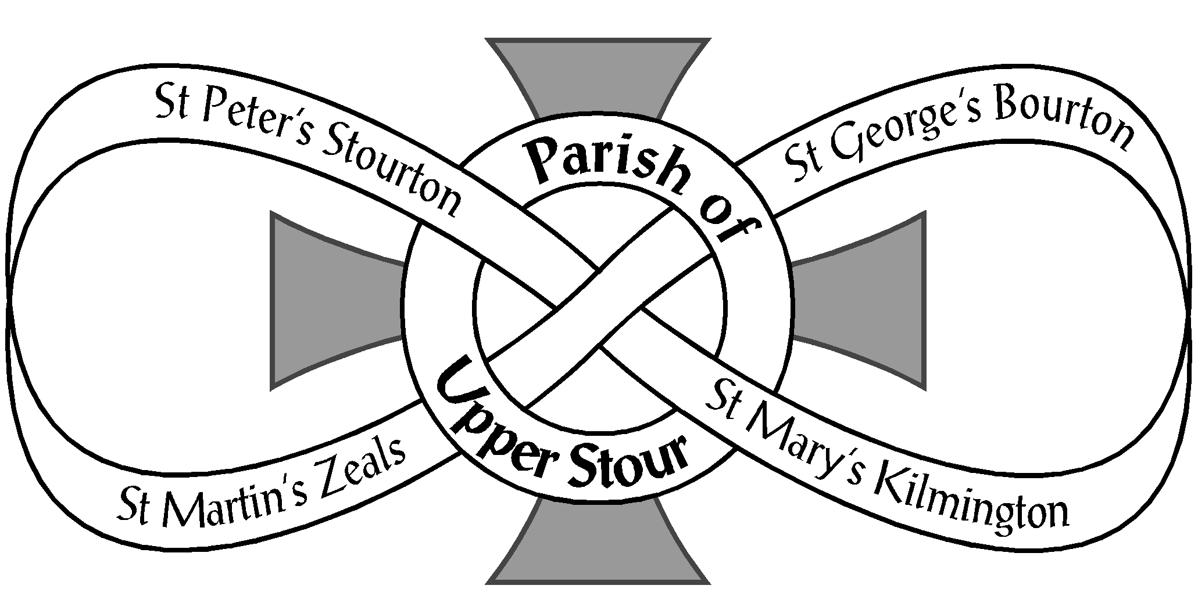

Looking to God, Looking to Care, Looking to Grow

Minutes of The Annual Parish Meeting and Annual Parochial Church Meeting
held Monday 26th October 2020 at 7.00 pm in Bourton Village Hall

ANNUAL PARISH MEETING
- Opening Prayers

- Apologies – Sue Evans, Tom Spencer, Colin Holman, Mona Tyler, Sue Todd, Catherine Spencer,
Tony Moorby, Cathy Moorby, Graham Poynton, Liz Kemp. A total of 17 attended the meetings.
3. Minutes of the last meeting 29th April 2019 – These had been on the website for some weeks.
Approval was proposed by Brian Martin and seconded by Margaret Martin. All agreed.

4. Proposal to disregard Church Warden Measure 6-year rule in line with the Churchwarden
Measure 2001 Point 3 – Proposed by Jane Joyce and seconded by Viv Sturt. All agreed.

5. Election of Churchwardens (Open to all those on the Civic and Church Electoral Rolls)
Rev. Ben explained that though we are one parish, each of the 4 churches has 2 churchwardens
and he thanked all 8 for their dedication. The following were re-elected as follows:-

St. Georges, Margaret Martin Proposer: Glenis Allen Seconder: Barbara Borwell
Bourton Harry Allen Caroline Worthington Viv Sturt
St. Mary’s Celia Cotton Sue Evans Carol Affleck
Kilmington Chris Reeves Ashley Kemp Vanessa Meeker
St. Peter’s, Jane Parker Celia Cotton Margaret Martin Stourton Crin Fearon Jane Parker Suzie Hoare
St. Martin’s, Sue Evans Celia Cotton Carol Affleck
Zeals Tom Spencer Jane Parker Jane Joyce
ANNUAL PAROCHIAL CHURCH MEETING
Open to those on the Church Electoral Roll (CER)
- Church Wardens’ reports on the fabric, goods and ornaments of each Church and presentation of Church Inventories (Pages 6 & 7 of Annual Report)
Jane Parker presented the inventory and terrier for St. Peters, Celia Cotton for St. Mary’s. Harry
Allen for St. George’s said that nothing had been added – Rev. Ben to sign after the meeting. And
similarly for St. Martin’s in Sue Evans and Tom Spencer’s absence, so Rev. Ben to sign afterwards.

- PCC Annual Report (Pages 3 & 4 of Annual Report)
This was warmly received, with no queries.

- Treasurer’s Report and Adoption of Accounts (End of Annual Report)
Rev. Ben thanked Brian Martin as it was always a challenging time for Treasurers. He also thanked all the LCC treasurers. The Accounts were adopted. Brian Martin said that the parish had paid the parish share last year but reserve funds had been reduced by the end of last year. This year, due to Covid and therefore no fund-raising, the parish had managed £47,000 out of £55,000.
- 1 -

He went on to say that voluntary giving will be less than £50,000 but the parish share will be more,
and of course there are still running costs, care of the buildings and insurance. The Parish Share
is voluntary and three of our churches have been able to pay in full but one has not.
The Deanery Treasurer has said that there are two options 1. Increase parish share and keep the
number of priests or, 2. Decrease the parish share and reduce the number of priests. He was minded
to increase the share and keep the number of priests. Rev. Ben added that there had been one saving
- that of there no longer being a parish administrator during these difficult times. This was
acknowledged and appreciated. There were no queries.

- Appointment of Examiner of PCC Accounts – The proposal was to carry on with Mr. Willis.
Proposer Margaret Martin and seconder Ashley Kemp. All agreed.

- Election of Deanery Synod representatives x 2 (3 yr. term – open to those on the CER)
Rev. Ben explained that with the reduction of the Church Electoral Roll to 95 we were due
two representatives. Malcolm Affleck was proposed by Val Rowe and seconded by John Rowe.
Chris Reeves was proposed by Ashley Kemp and seconded by Vanessa Meeker. All agreed
and both were thanked for continuing in this role.
6. Deanery Synod Report (Page 8 of Annual Report) (Open to those on the CER)
There were no queries on Malcolm Affleck’s report.

7. Appointment of Electoral Roll Officer (Open to those on the CER)
Rev. Ben asked Elizabeth Hames if she would be happy to continue in this role and she replied in the
affirmative. She was proposed by Val Rowe and seconded by Malcolm Affleck. All approved and
were grateful.

8. Report on and reception of the Church Electoral Roll (Page 9 of Annual Report)
Rev. Ben, with Elizabeth Hames’ agreement encouraged people to go on to the Electoral Roll
and forms were going back into the churches.
9. Proposal to allow for six elected members to the PCC as per CRR2020 M15(9) and for elected
members to serve yearly terms as per CRR2020 M16(2)
Proposer Jane Joyce and Seconder Brian Martin – all agreed .

10. Election of Parochial Church Council representatives x 6 (Open to those on the CER)
The following 6 nominations were made but no election was necessary as there were no other
nominations:-
Colin Holman Proposer Margaret Martin Seconder Brian Martin
George Bullivant Jane Joyce Jane Parker
Caroline Worthington Jane Joyce Val Donnell
John Rowe Joan Lane Chris Reeves
Jane Joyce Sue Evans Sue Todd
Ashley Kemp Celia Cotton Sue Evans

11. Vice-Chairman’s Report (Page 9 of Annual Report)
Rev. Ben thanked Crin Fearon for chairing the PCC during the interregnum. Brian Martin added his
thanks for all her work. She said she was ably assisted. Her report was received warmly with hearty
thanks.

- 2 -

12. Reports (Page 10 onwards of Annual Report)
No queries on any reports but Margaret Martin made the point that verbal reports during services
were vibrant and gave people the chance to comment, but of course not everyone heard the reports.
Crin Fearon endorsed the presentation of reports during services and Brian Martin added that it
was useful still to have a written record in the APCM report. Rev.Ben said that he was happy for
reports to be presented during services and additionally they should go on the website. It was also
mooted that reports could be published in the Parish Magazine – to be discussed further.

13. Any other business - Christmas fundraising.
Jane Parker explained that the W.I. were planning to decorate St. Peter’s through December for
Christmas and also with decorations dedicated to Covid (NHS, Carers etc.). It is to tie in to the
Stourhead Christmas Light event and hopefully attract their visitors and fund raise for the
Parish as a whole. Brian Martin asked if there would be Christmas music and was assured that
there would be. Jane Joyce asked if there would be a board to explain what it was all about
(as outside the National Trust for instance and not part of the Light Show) and was assured
that there would be. Jane Joyce offered to do a stewarding rota and asked if Ashley Kemp could
instruct volunteer stewards on the card readers. He would. Jane Joyce welcomed offers of
stewarding – probably 2 hr. stints between 4.00 pm and 8.00 pm during the December light
event nights. Celia Cotton offered to look after the sale of produce, which was welcomed as
usually very good for fund-raising. Refreshments were not possible of course.

Crin Fearon thanked the Secretary as did Brian Martin. Rev. Ben was asked how he was finding
things this year. He said that Upper Stour is the place to be and that hospitality is very evident. It’s
been a weird year but he’s enjoyed it. He went on to say that he is planning a “Vision Day”.

14. Date of next meeting – 13th May 2021 Venue tbc

15. Closing Prayers

- 3 -

