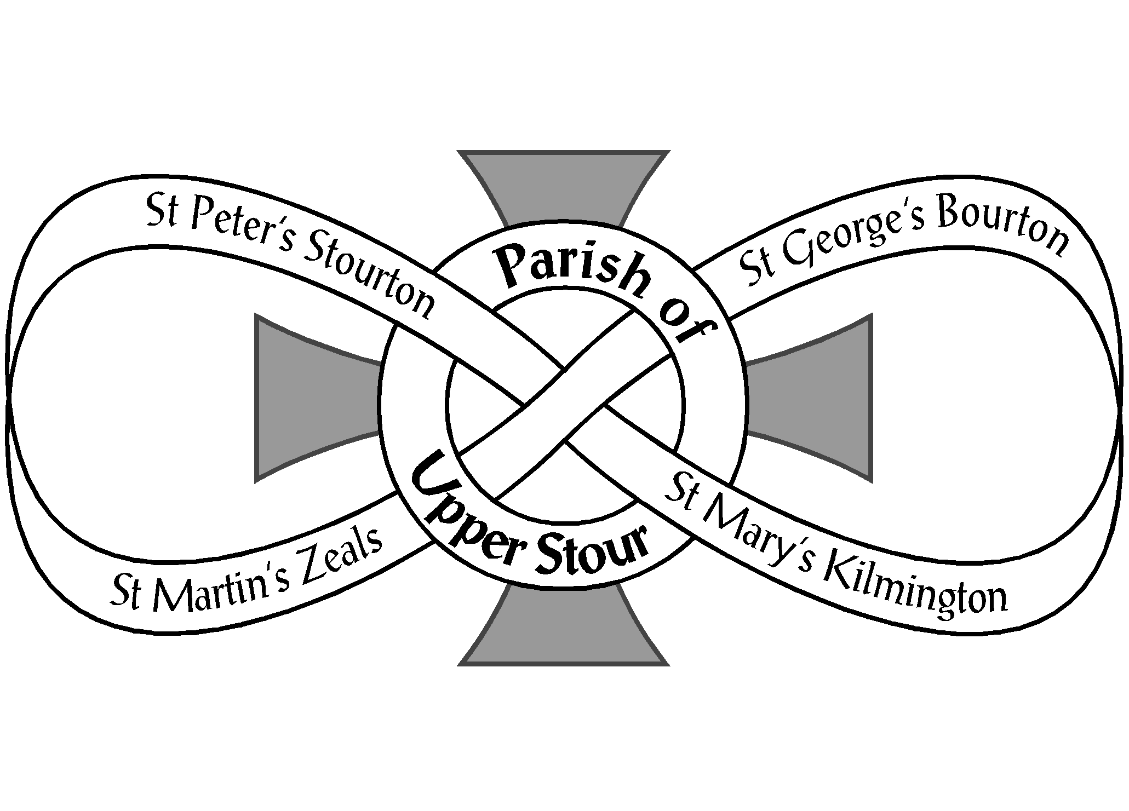
Parochial Church Council of Upper Stour
Looking to God, Looking to Care, Looking to Grow
01747 840221
www.upperstour.co.uk
parishoffice@upperstour.co.uk
The Rectory, Portnells Lane, Zeals, BA12 6PG
Registered in England as a Charity Number: 1131161

Wedding Form

Contact Details
Bride |  |  |  | Groom
Name: |  |  |  | Name:
Address: |  |  |  | Address:
Email: |  |  |  | Email:
Phone: |  |  |  | Phone:
Home Parish: |  |  |  | Home Parish:
We have spoken to our home parish(es) and asked them to publish our banns: Yes / Not yet
Service Details
Date and Time of Wedding:
Church:
Readings
Biblical Reading:
Additional Reading:
Hymns
Hymn 1
Hymn 2
Hymn 3
Music
Before the Service |  |  |  |  |  | Organist or MP3
Entrance of the Bride |  |  |  |  |  | Organist or MP3
Signing of the Registers |  |  |  |  |  | Organist or MP3
Exit of the Bride and Groom |  |  |  |  |  | Organist or MP3
Extras
Organist |  |  |  |  | Yes / No
Bells: |  |  |  |  | Yes / No
Extra Marriage Certificates |  |  |  |  | Number:
Church Florists |  |  |  |  | Yes / No
Details of Private Florist

