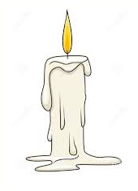
CHRISTMAS MUSICAL
ILLUMINATIONS

THE THREE COUNTIES CHOIR
Conductor: MICHAEL BROWN
ST. PETER’S Church, STOURTON
Thursday, December 12th at 7.30 pm
Tickets £10 Jane Joyce 01747 840149 j-joyce@dircon.co.uk
also Bourton & Zeals shops In aid of St. Peter’s roof

