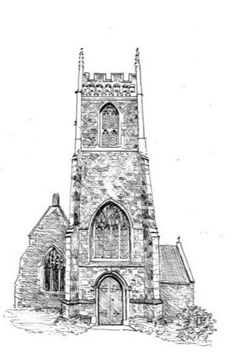
TOWER SOCIETY
TALK
6.45 pm for 7 pm Tuesday 12th November 2019
St Mary’s Church Kilmington BA12 6RD
How to reduce your risk of Alzheimer’s disease - and improve your memory
Professor John Harrison PhD
Light Refreshments £10 at the door
To raise money to restore the Tower
The Fifth of the Tower Society Talks

