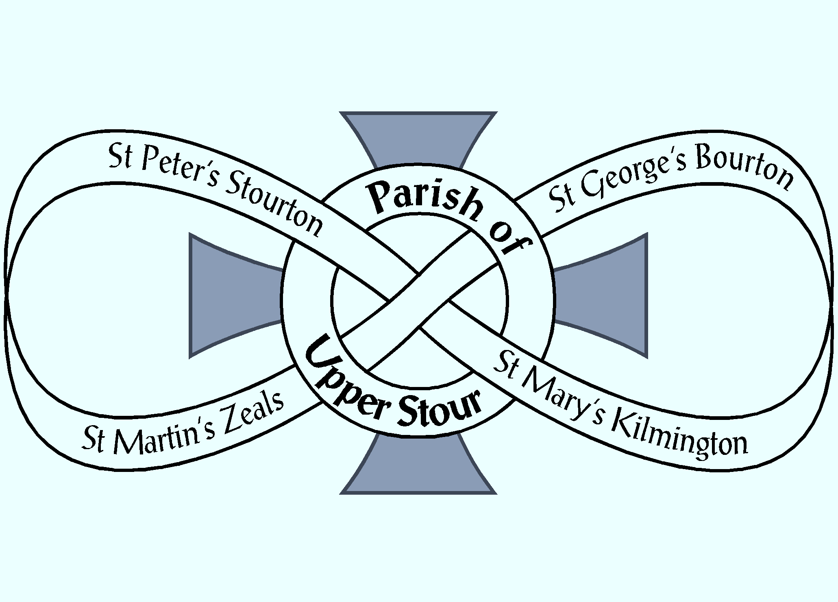

Yew tree wood available now in St.Martin’s churchyard
Recently felled and now in log pieces 1.5m > 2.1m long
and some ‘slices’.
First come, first served… please contact
ChurchWarden Miss Sue Evans 01747 840600

Donations please, to help with St.Martin’s LCC, Zeals
maintenance costs of the church and churchyard
by Cheque, BACS or cash

