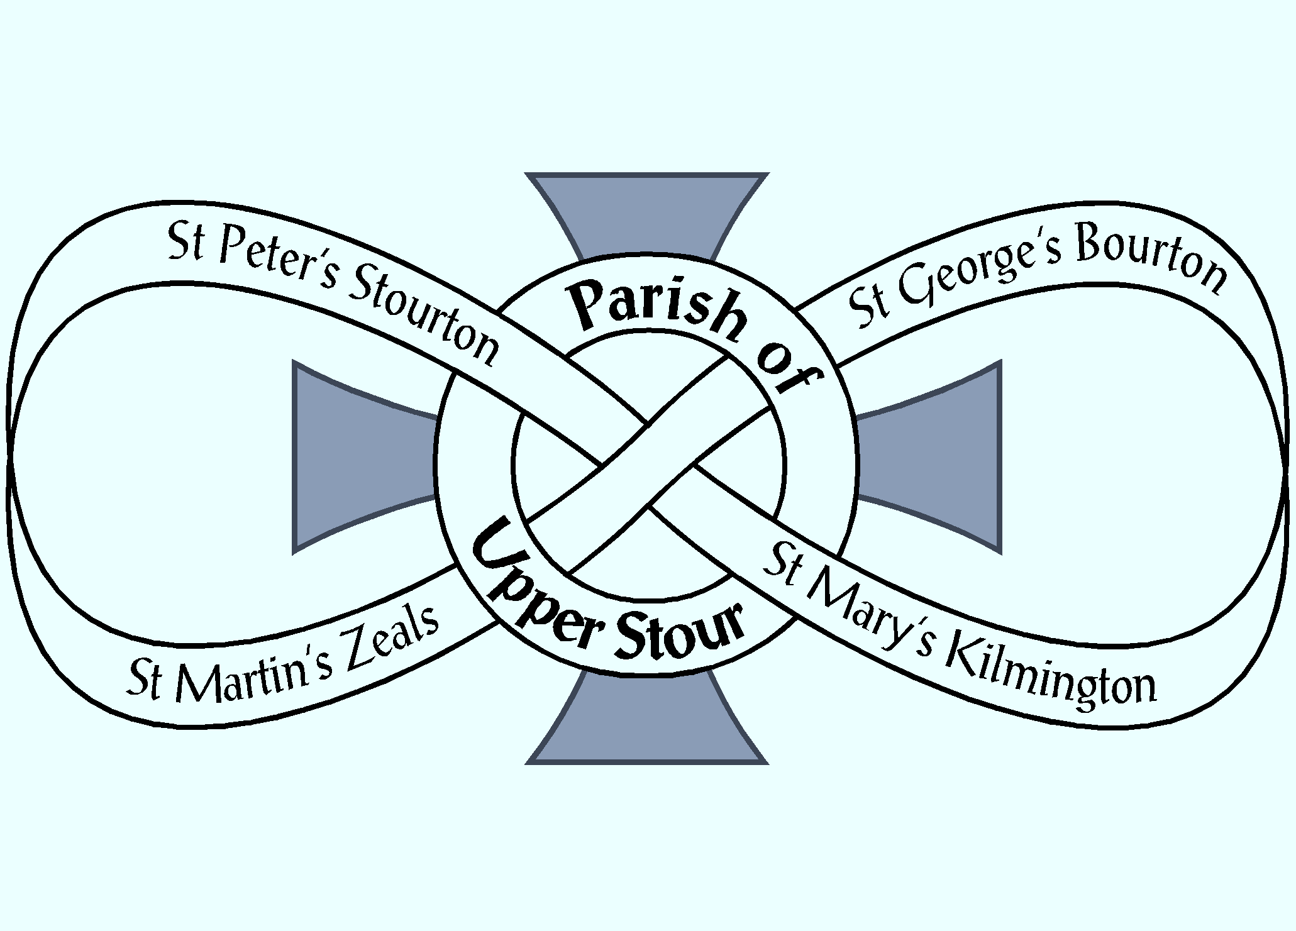

Looking to God, Looking to Care, Looking to Grow

NOTICES

Week commencing 13th May 2019

MON 9.00 am MORNING PRAYER – St George’s, Bourton
10.30 am COFFEE & COMMUNION – Westfields, Zeals

WED 10.00 am CHURCHES TOGETHER QUIET DAY –
Sedgehill Manor, Shaftesbury SP7 9HQ. Please let Kirsty know today if you would like to attend. Please bring a packed lunch. The day is free but donations appreciated.
5.00 pm PRAYER TIME – St Martin’s, Zeals

THURS 9.00 am MORNING PRAYER – St Mary’s, Kilmington

FRI 6.00 pm CHOIR PRACTICE – St Martin’s, Zeals

NEXT SUNDAY
Sunday 19th May – FIFTH SUNDAY AFTER EASTER
10.00 am PARISH COMMUNION – St Martin’s, Zeals

THY KINGDOM COME 2019 – We are called to take part in the wave of prayer from Ascension 30th May to Pentecost 9th June. More information at: www.thykingdomcome.global/about-us
Sunday 30th June – SONGS OF PRAISE – Stourhead. Please come and join us to share the gospel in words and music, FREE entry and parking. Hymn/song choices to Kirsty ASAP please.

If you are a visitor to this church, we hope that you will feel at home.
Do make yourself known to us
We hope you will be able to join us for refreshments after the 10.00 am service
Contact: Parish Office 01747 840221 Email: parishoffice@upperstour.co.uk
Facebook Page: Parish of Upper Stour Website: upperstour.co.uk

