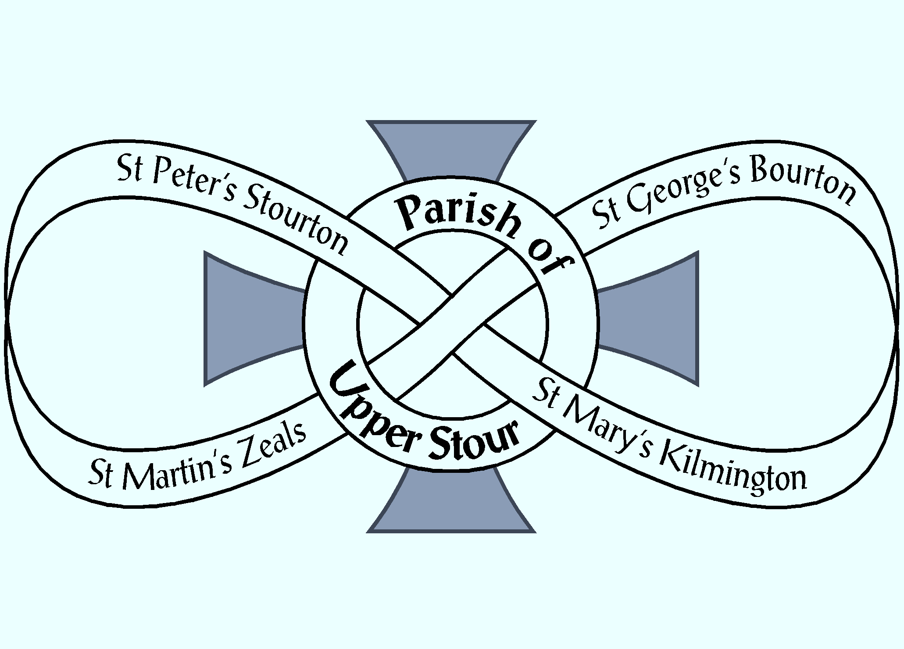

Looking to God, Looking to Care, Looking to Grow

NOTICES
Week commencing 24th February 2019

MON 9.00 am MORNING PRAYER – St George’s, Bourton
10.30 am COFFEE & COMMUNION – Westfields, Zeals

TUES GRAHAM’S DAY OFF
7.00 pm COMMISSIONING OF CAROLINE WORTHINGTON (and
others) as Lay Pastoral Assistant, Dilton Marsh Church. All Welcome!

WED 5.00 pm PRAYER TIME – St Martin’s, Zeals
7.00 pm CHURCHES TOGETHER COMMITTEE - URC, Boar Street, Mere
7.30 pm CHURCHES TOGETHER AGM - URC, Boar Street, Mere
7.30 pm KILMINGTON HOUSEGROUP – Dovecote Barn, Kilmington

THURS 9.00 am MORNING PRAYER – St Mary’s, Kilmington
10.00 am BOURTON HOUSEGROUP – Randalls Barn, Bourton

FRI 8.30 am MORNING PRAYER – St Peter’s, Stourton
11.00 am WOMEN’s WORLD DAY OF PRAYER,
St. Mary’s RC Church, Mere
6.00 pm CHOIR PRACTICE – St Martin’s, Zeals

SAT 10.00am MARRIAGE PREPARATION DAY – Whitesheet Academy, Zeals
10.30 am COFFEE MORNING – Village Hall, Zeals

NEXT SUNDAY
Sunday 3rd March – THE SUNDAY NEXT BEFORE LENT
8.00 am HOLY COMMUNION – St George’s, Bourton
10.00 am US@10 – St George’s, Bourton

If you are a visitor to this church, we hope that you will feel at home.
Do make yourself known to us
We hope you will be able to join us for refreshments after the 10.00 am service
Contact: Parish Office 01747 840221 Email: parishoffice@upperstour.co.uk
Facebook Page: Parish of Upper Stour Website: upperstour.co.uk

Looking to God, Looking to Care, Looking to Grow

Sunday 24th February 2019 The Second Sunday Before Lent (Year C)
10.00am Parish Communion St Peter’s, Stourton
Banns for Richard Crockett and Francesca Hallett

Hymn: 9 All creatures of our God and King

Collect: Almighty God, give us reverence for all creation and respect for every person, that we may mirror your likeness in Jesus Christ our Lord. Amen

Readings: Gen. 2. 4b – 9; read by Sue Evans
Rev. 4; read by Tom Spencer

Hymn: 114 Eternal Father, strong to save

Gospel: Luke 8. 22 – 25; read by Jane Parker

Sermon: Reverend Graham Perryman

Intercessions: John Rowe

Offertory Hymn: 426 Praise to the holiest in the height

Communion Hymn: 83 Christ’s is the world in which we move

Post Communion: God our creator, by your gift the tree of life was set at the heart of the earthly paradise, and the bread of life at the heart of your Church: may we who have been nourished at your table on earth be transformed by the glory of the Saviour’s cross and enjoy the delights of eternity;
through Jesus Christ our Lord. Amen.

Recessional Hymn: 293 Lead us, heavenly Father, lead us

