NOTICES
Week commencing 10th February 2019

MON 9.00 am MORNING PRAYER – St George’s, Bourton
10.30 am COFFEE & COMMUNION – Westfields, Zeals
4.30 pm ZEALS LCC – Parish Room, Zeals

WED 5.00 pm PRAYER TIME – St Martin’s, Zeals
6.30 pm BISHOP MOSES (South Sudan)
at The Minster Church, Warminster.
7.30 pm KILMINGTON HOUSEGROUP – Dovecote Barn, Kilmington

THURS 9.00 am MORNING PRAYER – St Mary’s, Kilmington
10.00 am BOURTON HOUSEGROUP – Randalls Barn, Bourton

FRI GRAHAM’S DAY OFF
8.30 am MORNING PRAYER – St Peter’s, Stourton
6.00 pm CHOIR PRACTICE – St Martin’s, Zeals

SAT GRAHAM’S DAY OFF

NEXT SUNDAY
Sunday 17th February – THE THIRD SUNDAY BEFORE LENT
8.00 AM HOLY COMMUNION – St Martin’s, Zeals
10.00 AM US@10 – St Martin’s, Zeals
BANNS FOR RICHARD CROCKETT & FRANCESCA HALLETT

FUTURE EVENTS
Tue. 19th Feb 2pm Service of Thanksgiving for Betty Chapple, Stourton
Sat. March 9th, 11.30am, Service of Thanksgiving for Margaret Trussler, Stourton
Sat. April 26th, 11.00am, Service of Thanksgiving for Anne Corrie, Bourton

MISSING: At Bourton last Sunday, someone may have taken home the wrong walking stick – a longer one than their own stick. If you know who this could be, please let Graham know, and he will arrange a swap with Wendy Mallett, who took home a shorter stick than the one with which she arrived. Many thanks.

If you are a visitor to this church, we hope that you will feel at home.
Do make yourself known to us
We hope you will be able to join us for refreshments after the 10.00 am service
Contact: Parish Office 01747 840221 Email: parishoffice@upperstour.co.uk
Facebook Page: Parish of Upper Stour Website: upperstour.co.uk

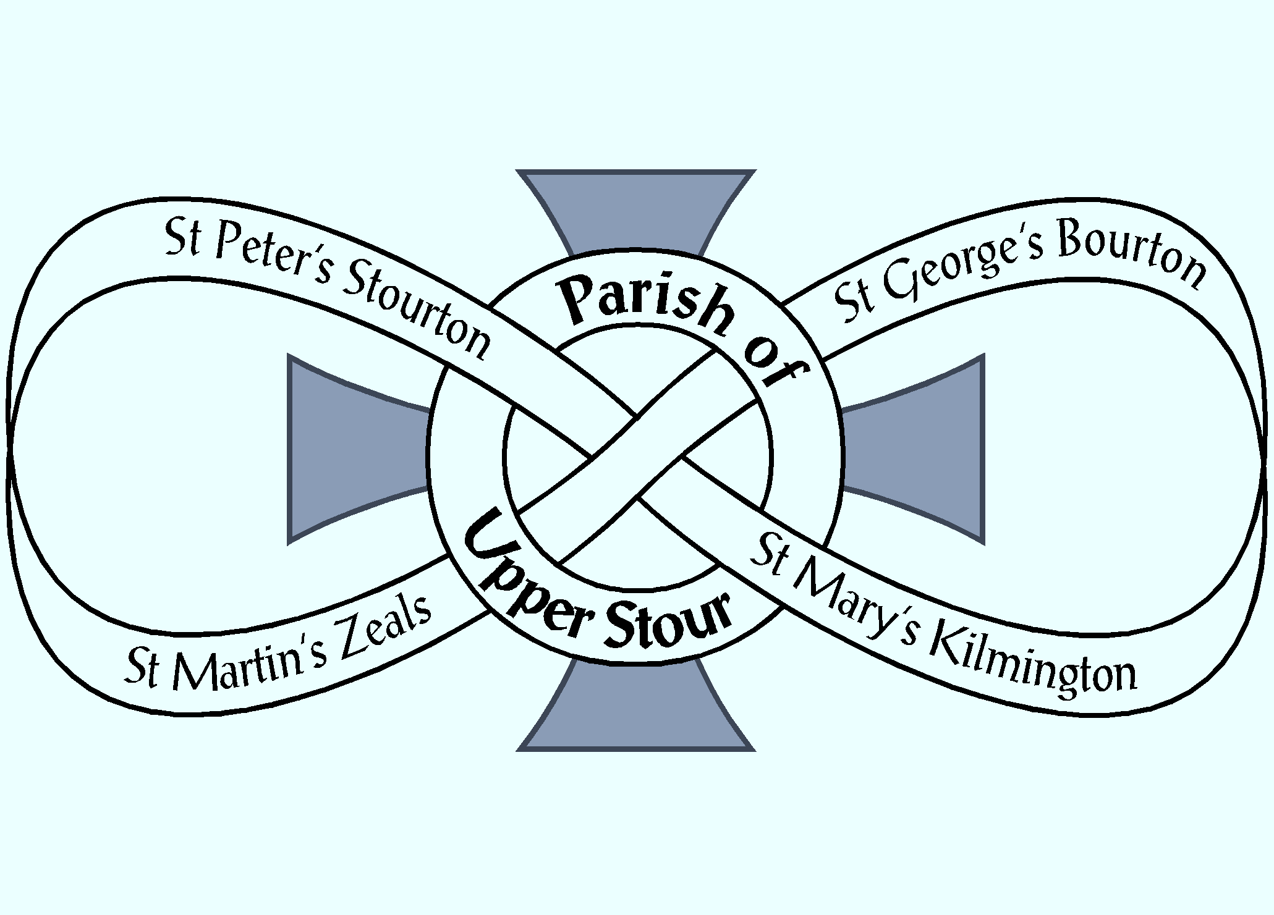

Looking to God, Looking to Care, Looking to Grow

Sunday 10th February 2019 The Fourth Sunday Before Lent (Year C)
10.00am Holy Communion and baptism of Willow Lillian Grace Brewer
St Mary’s, Kilmington
Banns for Richard Crockett and Francesca Hallett

Hymn: 242 Immortal, Invisible, God only wise

Collect: Lord of hosts of heaven, our salvation and our strength, without you we are lost: guard us from all that harms
or hurts and raise us when we fall; through Jesus Christ
our Lord. Amen

Readings: Luke 5. 1 – 11; read by Peter Booth

Hymn: 106 Dear Lord and Father of mankind

Sermon: Reverend Graham Perryman

Intercessions: Crin Fearon

Offertory Hymn: 30 And can if be that I should gain

Communion Hymn: 235 I the Lord of sea and sky

Post Communion: Go before us, Lord, in all we do with your most gracious favour, and guide us with your continual help,
that in all our works begun, continued and ended in you,
we may glorify your holy name, and finally by your mercy receive everlasting life; through Jesus Christ our Lord. Amen.

Recessional Hymn: 212 Holy, holy, holy, Lord God almighty

