NOTICES

Week commencing 27th January 2019

MON GRAHAMS DAY OFF
9.00 am MORNING PRAYER – St George’s, Bourton
10.30 am COFFEE & COMMUNION – Westfields

TUES GRAHAMS DAY OFF
7.00 pm PAROCHIAL CHURCH COUNCIL – Parish Room, Zeals

WED 5.00 pm PRAYER TIME – St Martin’s, Zeals
7.30 pm KILMINGTON HOUSEGROUP – Dovecote Barn, Kilmington

THURS 9.00 am MORNING PRAYER – St Mary’s, Kilmington
10.00 am BOURTON HOUSEGROUP – Randalls Barn, Bourton
2.00 pm FUNERAL OF ROGER COWLISHAW – Yeovil Crematorium
2.00 pm BOURTON LCC – 3, Mill Rise, Bourton

FRI 8.30 am MORNING PRAYER – St Peter’s, Stourton
6.00 pm CHOIR PRACTICE – St Martin’s, Zeals

SAT 10.00 am – 4.00 pm MARRIAGE PREPARATION DAY
– Memorial Hall, Stourton
10.30 am COFFEE MORNING – Parish Room, Zeals

NEXT SUNDAY
Sunday 3RD February – THE FOURTH SUNDAY OF EPIPHANY

If you are a visitor to this church, we hope that you will feel at home.
Do make yourself known to us
We hope you will be able to join us for refreshments after the 10.00 am service
Contact: Parish Office 01747 840221 Email: parishoffice@upperstour.co.uk
Facebook Page: Parish of Upper Stour Website: upperstour.co.uk

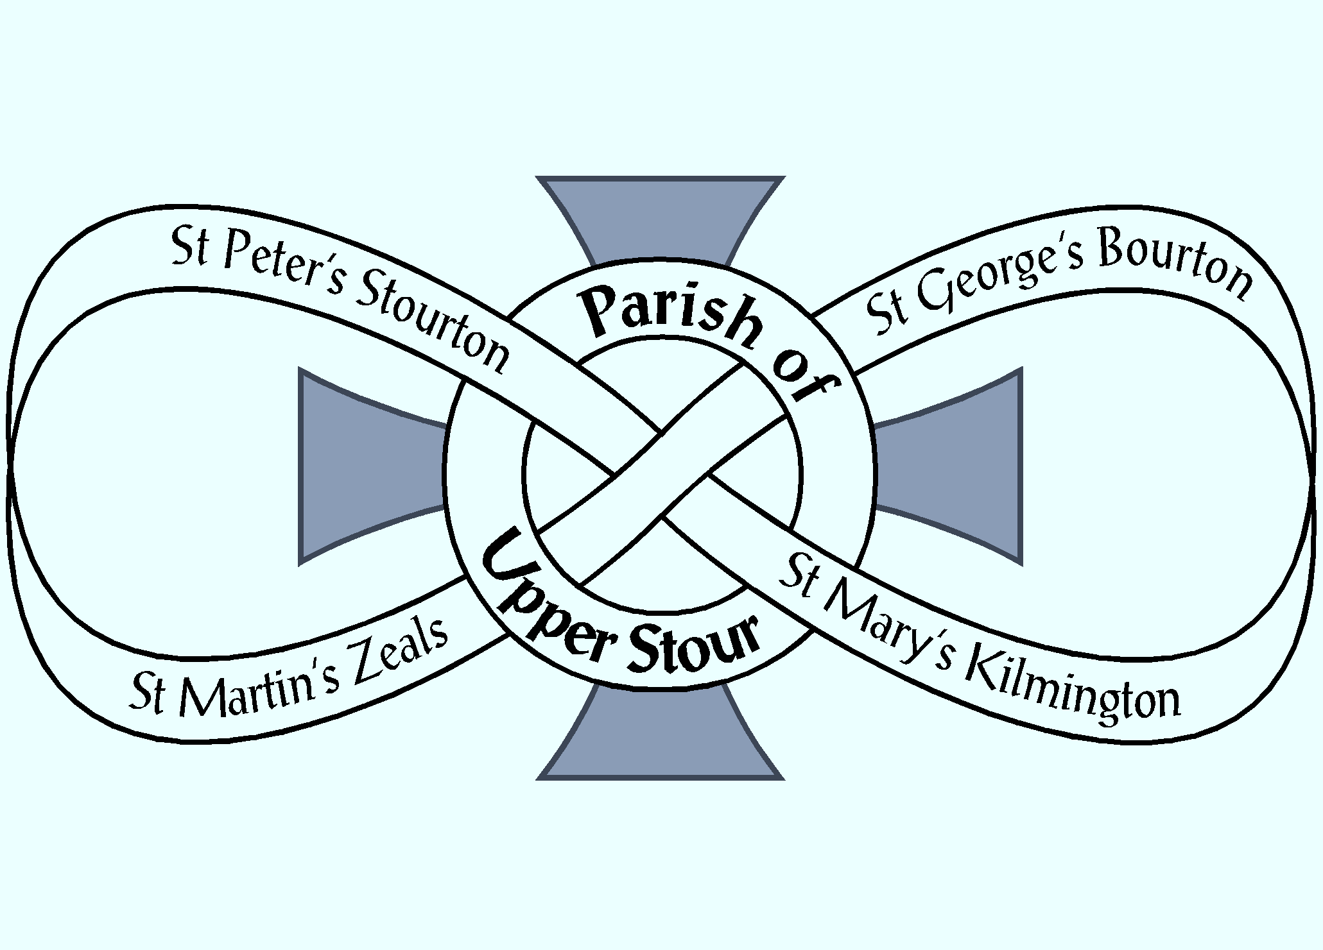

Looking to God, Looking to Care, Looking to Grow

Sunday 27th January 2019 Third Sunday after Epiphany (Year C)
10.00am Parish Communion St Peter’s, Stourton

Hymn: 362 O for a thousand tongues to sing

Collect: God of heaven, you send the gospel to the ends of the earth and your messengers to every nation: send your Holy Spirit to transform us by the good news of everlasting life in Jesus Christ our Lord. Amen

Readings: Neh. 8. 1 – 3; 5 – 6; 8 – 10; [OT. p. 467]
read by Tom Spencer
1 Cor. 12. 12 – 31a; [NT. p. 186]
read by Catherine Spencer

Hymn: 198 Hark the glad sound

Gospel: Luke 4. 14 – 21; [NT. p. 187] read by George Bullivant

Sermon: Reverend Graham Perryman

Intercessions: Corinna Howard

Offertory Hymn: 259 Jerusalem the golden

Communion Hymn: 280 Jesus, stand among us

Post Communion: Generous Lord, in word and eucharist we have proclaimed the mystery of your love: help us so to live out our days that we may be signs of your wonders in the world; through Jesus Christ our Saviour. Amen.

Recessional Hymn: 270 Jesus is Lord

