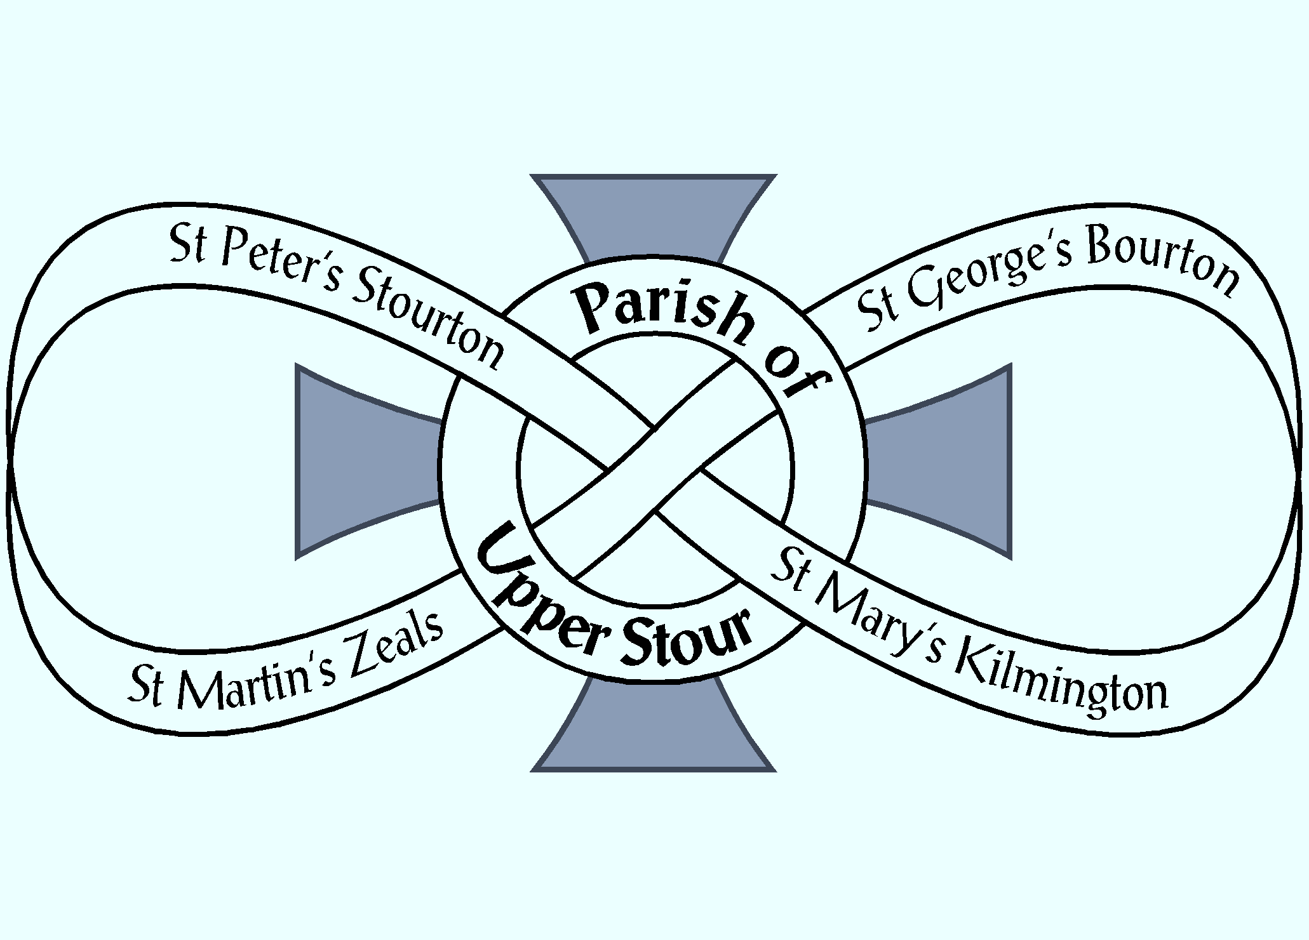

Looking to God, Looking to Care, Looking to Grow
NOTICES
Week commencing 20th January 2019

MON 9.30 am WEEK OF PRAYER FOR CHRISTIAN UNITY – St George’s, Bourton
12.30 pm ZEALS SOUP LUNCH – Village Hall
4.00 pm VISION GROUP – Parish Room

TUES 9.30 am WEEK OF PRAYER FOR CHRISTIAN UNITY – Maiden Bradley
1.45 pm FUNERAL OF MADELEINE DIXON
– Salisbury Crematorium
7.30 pm KILMINGTON HOUSEGROUP
– Dovecote Barn, Kilmington

WED 9.30 am WEEK OF PRAYER FOR CHRISTIAN UNITY – West Knoyle

THU 9.30 am WEEK OF PRAYER FOR CHRISTIAN UNITY – St Michael’s, Mere
10.00 am BOURTON HOUSEGROUP
– Randalls Barn, Bourton

FRI 9.30 am WEEK OF PRAYER FOR CHRISTIAN UNITY – St Martin’s, Zeals
11.00 am PILGRIM 2.5 THE LORDS PRAYER
– The Rectory, Zeals
6.00 pm CHOIR PRACTICE – St Martin’s, Zeals

SAT 5.30 pm BISHOP ANDREW RUMSEY WELCOMED AS THE NEW BISHOP OF RAMSBURY – Salisbury Cathedral

NEXT SUNDAY
Sunday 27th JANUARY – 4th SUNDAY OF EPIPHANY
10.00 am PARISH COMMUNION – Stourton

If you are a visitor to this church, we hope that you will feel at home. Do make yourself known to us
Contact: Parish Office 01747 840221 Email: parishoffice@upperstour.co.uk
Facebook Page: Parish of Upper Stour
Website: upperstour.co.uk

Looking to God, Looking to Care, Looking to Grow
NOTICES
Week commencing 20th January 2019

MON 9.30 am WEEK OF PRAYER FOR CHRISTIAN UNITY – St George’s, Bourton
12.30 pm ZEALS SOUP LUNCH – Village Hall
4.00 pm VISION GROUP – Parish Room

TUES 9.30 am WEEK OF PRAYER FOR CHRISTIAN UNITY – Maiden Bradley
1.45 pm FUNERAL OF MADELEINE DIXON
– Salisbury Crematorium
7.30 pm KILMINGTON HOUSEGROUP
– Dovecote Barn, Kilmington

WED 9.30 am WEEK OF PRAYER FOR CHRISTIAN UNITY – West Knoyle

THU 9.30 am WEEK OF PRAYER FOR CHRISTIAN UNITY – St Michael’s, Mere
10.00 am BOURTON HOUSEGROUP
– Randalls Barn, Bourton

FRI 9.30 am WEEK OF PRAYER FOR CHRISTIAN UNITY – St Martin’s, Zeals
11.00 am PILGRIM 2.5 THE LORDS PRAYER
– The Rectory, Zeals
6.00 pm CHOIR PRACTICE – St Martin’s, Zeals

SAT 5.30 pm BISHOP ANDREW RUMSEY WELCOMED AS THE NEW BISHOP OF RAMSBURY – Salisbury Cathedral

NEXT SUNDAY
Sunday 27th JANUARY – 4th SUNDAY OF EPIPHANY
10.00 am PARISH COMMUNION – Stourton

If you are a visitor to this church, we hope that you will feel at home. Do make yourself known to us
Contact: Parish Office 01747 840221 Email: parishoffice@upperstour.co.uk
Facebook Page: Parish of Upper Stour
Website: upperstour.co.uk

Looking to God, Looking to Care, Looking to Grow
NOTICES
Week commencing 20th January 2019

MON 9.30 am WEEK OF PRAYER FOR CHRISTIAN UNITY – St George’s, Bourton
12.30 pm ZEALS SOUP LUNCH – Village Hall
4.00 pm VISION GROUP – Parish Room

TUES 9.30 am WEEK OF PRAYER FOR CHRISTIAN UNITY – Maiden Bradley
1.45 pm FUNERAL OF MADELEINE DIXON
– Salisbury Crematorium
7.30 pm KILMINGTON HOUSEGROUP
– Dovecote Barn, Kilmington

WED 9.30 am WEEK OF PRAYER FOR CHRISTIAN UNITY – West Knoyle

THU 9.30 am WEEK OF PRAYER FOR CHRISTIAN UNITY – St Michael’s, Mere
10.00 am BOURTON HOUSEGROUP
– Randalls Barn, Bourton

FRI 9.30 am WEEK OF PRAYER FOR CHRISTIAN UNITY – St Martin’s, Zeals
11.00 am PILGRIM 2.5 THE LORDS PRAYER
– The Rectory, Zeals
6.00 pm CHOIR PRACTICE – St Martin’s, Zeals

SAT 5.30 pm BISHOP ANDREW RUMSEY WELCOMED AS THE NEW BISHOP OF RAMSBURY – Salisbury Cathedral

NEXT SUNDAY
Sunday 27th JANUARY – 4th SUNDAY OF EPIPHANY
10.00 am PARISH COMMUNION – Stourton

If you are a visitor to this church, we hope that you will feel at home. Do make yourself known to us
Contact: Parish Office 01747 840221 Email: parishoffice@upperstour.co.uk
Facebook Page: Parish of Upper Stour
Website: upperstour.co.uk

