NOTICES

Week commencing 13th January 2019

MON 9.00 am MORNING PRAYER – St George’s, Bourton
10.30 am COFFEE & COMMUNION – Westfields
4.45 pm CHURCHWARDENS MEETING – Randalls Barn, Bourton

TUES 10.00 am FUNERAL OF MARGARET TRUSSLER – West Wilts Crematorium, Semington – close family only.
[A memorial service will take place at 11.30 am on 9th March,
St Peter’s, Stourton.]

WED 5.00 pm PRAYER TIME – St Martin’s, Zeals

THURS 9.00 am MORNING PRAYER – St Mary’s, Kilmington
3.30 pm DEANERY MISSION & PASTORAL COMMITTEE MEETING
– Upton Lovell

FRI 9.00 am BOURTON S & P COMMITTEE – St George’s School, Bourton
9.30 am WEEK OF PRAYER FOR CHRISTIAN UNITY PRAYERS
– St Mary’s, Mere
6.00 pm CHOIR PRACTICE – St Martin’s, Zeals

SAT 9.30 am WEEK OF PRAYER FOR CHRISTIAN UNITY PRAYERS
– United Reformed Church, , Mere
11.00 am MAGAZINE DISTRIBUTORS COFFEE MORNING,
- Parish Room, Zeals

NEXT SUNDAY
Sunday 20th January – THE THIRD SUNDAY OF EPIPHANY
10.00 am CHURCHES TOGETHER IN MERE AND DISTRICT SERVICE
– Maiden Bradley Church

FUTURE EVENTS
Tuesday 22nd January 1.45 pm FUNERAL OF MADELEINE DIXON
– Salisbury Crematorium

If you are a visitor to this church, we hope that you will feel at home.
Do make yourself known to us
We hope you will be able to join us for refreshments after the 10.00 am service
Contact: Parish Office 01747 840221 Email: parishoffice@upperstour.co.uk
Facebook Page: Parish of Upper Stour Website: upperstour.co.uk

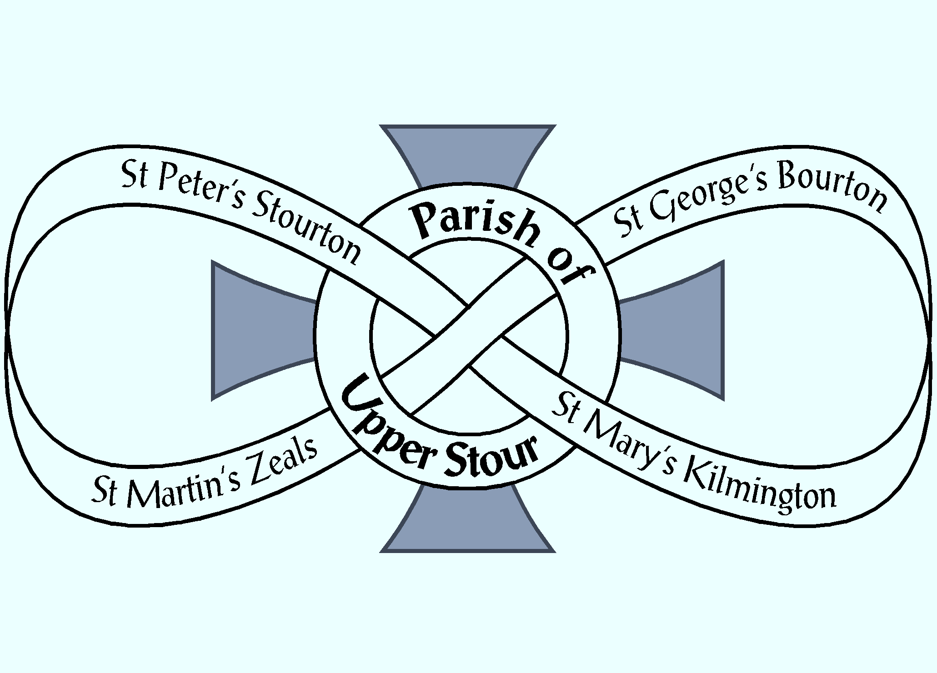

Looking to God, Looking to Care, Looking to Grow

Sunday 13th January 2019 The Baptism of Christ (Year C)
10.00am Parish Communion St Martin’s, Zeals

Hymn: 394 O Worship the Lord in the beauty of holiness

Collect: Heavenly Father at the Jordan you revealed Jesus as your Son: may we recognise him as our Lord and know ourselves to be your beloved children; through Jesus Christ our Saviour. Amen

Readings: Isa. 43. 1 – 7; [OT. p. 698] read by Lesley Love
Acts. 8. 14 - 17; [NT. p. 134] read by Tom Wheare

Hymn: 216 How firm a foundation

Gospel: Luke 3. 15 - 17; 21 – 22; [NT. p. 64] read by David Corbin

Sermon: Reverend Graham Perryman

Intercessions: Barbara Borwell

Offertory Hymn: 356 O breath of life come sweeping though us

Communion Hymn: 383 O love, how deep, how broad, how high

Post Communion: Lord of all time and eternity, you opened the heavens and revealed yourself as Father in the baptism of Jesus your beloved Son: by the power of your Spirit complete the heavenly work of our rebirth through the waters of the new creation; through Jesus Christ our Lord. Amen.

Recessional Hymn: 172 God is working his purpose out

NOTICES

Week commencing 13th January 2019

MON 9.00 am MORNING PRAYER – St George’s, Bourton
10.30 am COFFEE & COMMUNION – Westfields
4.45 pm CHURCHWARDENS MEETING – Randalls Barn, Bourton

TUES 10.00 am FUNERAL OF MARGARET TRUSSLER – West Wilts Crematorium, Semington – close family only.
[A memorial service will take place at 11.30 am on 9th March,
St Peter’s, Stourton.]

WED 5.00 pm PRAYER TIME – St Martin’s, Zeals

THURS 9.00 am MORNING PRAYER – St Mary’s, Kilmington
3.30 pm DEANERY MISSION & PASTORAL COMMITTEE MEETING
– Upton Lovell

FRI 9.00 am BOURTON S & P COMMITTEE – St George’s School, Bourton
9.30 am WEEK OF PRAYER FOR CHRISTIAN UNITY PRAYERS
– St Mary’s, Mere
6.00 pm CHOIR PRACTICE – St Martin’s, Zeals

SAT 9.30 am WEEK OF PRAYER FOR CHRISTIAN UNITY PRAYERS
– United Reformed Church, , Mere
11.00 am MAGAZINE DISTRIBUTORS COFFEE MORNING,
- Parish Room, Zeals

NEXT SUNDAY
Sunday 20th January – THE THIRD SUNDAY OF EPIPHANY
10.00 am CHURCHES TOGETHER IN MERE AND DISTRICT SERVICE
– Maiden Bradley Church

FUTURE EVENTS
Tuesday 22nd January 1.45 pm FUNERAL OF MADELEINE DIXON
– Salisbury Crematorium

If you are a visitor to this church, we hope that you will feel at home.
Do make yourself known to us
We hope you will be able to join us for refreshments after the 10.00 am service
Contact: Parish Office 01747 840221 Email: parishoffice@upperstour.co.uk
Facebook Page: Parish of Upper Stour Website: upperstour.co.uk

Looking to God, Looking to Care, Looking to Grow

Sunday 13th January 2019 The Baptism of Christ (Year C)
10.00am Parish Communion St Martin’s, Zeals

Hymn: 394 O Worship the Lord in the beauty of holiness

Collect: Heavenly Father at the Jordan you revealed Jesus as your Son: may we recognise him as our Lord and know ourselves to be your beloved children; through Jesus Christ our Saviour. Amen

Readings: Isa. 43. 1 – 7; [OT. p. 698] read by Lesley Love
Acts. 8. 14 - 17; [NT. p. 134] read by Tom Wheare

Hymn: 216 How firm a foundation

Gospel: Luke 3. 15 - 17; 21 – 22; [NT. p. 64] read by David Corbin

Sermon: Reverend Graham Perryman

Intercessions: Barbara Borwell

Offertory Hymn: 356 O breath of life come sweeping though us

Communion Hymn: 383 O love, how deep, how broad, how high

Post Communion: Lord of all time and eternity, you opened the heavens and revealed yourself as Father in the baptism of Jesus your beloved Son: by the power of your Spirit complete the heavenly work of our rebirth through the waters of the new creation; through Jesus Christ our Lord. Amen.

Recessional Hymn: 172 God is working his purpose out

